Project Name

Students :
Supervisor :
Semester : Aviv 2015

Project Description :
Modern flash-based solid-state drives contain aggressive 19nm scaling of floating-gate transistors. As a result, data is often stored with errors due to inter-cell interference, coupling, random-telegraph noise and more. The signal-to-noise ratio becomes even worse as density increases. In order to provide reliable data storage, system controller employs error-correcting algorithms.

The goal of this project is to design and implement an advanced error-correction soft-decision Reed-Solomon encoder and decoder.
Project Requirements:
- Pipelined architecture
- Minimal on chip memory
- Real time performance
- Maximum area efficiency
- Synthesis
- Physical design (layout)
Project Specifications:
- Clock Frequency : 150 MHz
- Area : 5x5 sq. mm
- Maximum number of IOs : 120
- Technology : Tower 0.18u CMOS
Development Stages / Design Flow | Tools
Software Simulation | C/Matlab
Architectural and Logic Design
HDL Implementation | VHDL/Verilog
Functional simulation | Ncsim/VCS
Synthesis | Design Compiler
Layout Design | First Encounter

Literature

Alternative solutions

Selected solution

Top Level Interface

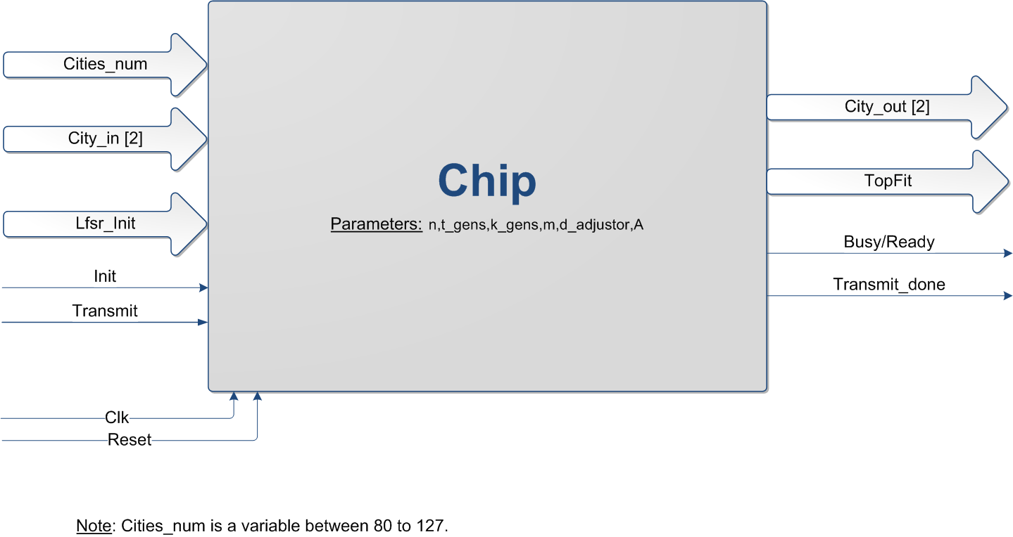
Top Level Architecture

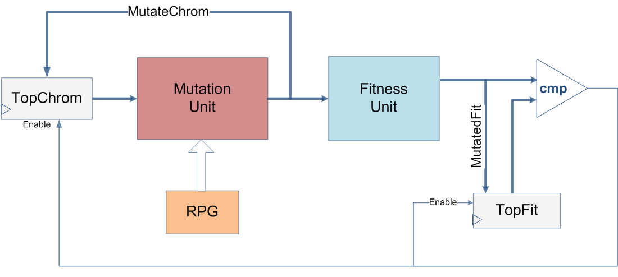

Provisional/Preliminary Schedule  Task A  Task B  Task C  Task D  Task E  Task F | Week  1-3  3-5  6-9  9-12  13  14

Please prepare a Gantt chart as follows: Gantt Chart Example:
Week 1 2 3 4 5 6 7 8 9 10 11 12 13 14 15
Software Simulation

Architectural and Logic Design

HDL Implementation

Functional simulation

Synthesis

Layout Design

Report

